**Ultrasonic HC-SR04 , Bluetooth HC-05 and MPU6050 sensor Project Basic Function Report**

Intro:

* This project call Bluetooth communication with the installation of Ultrasonic sensor and Gyro & Accelerometer.
* Sort of code enable the communication between an Arduino Board and Bluetooth module.
* Also it incorporates with an ultrasonic sensor to measure the distance and a gyro & accelerometer is to measure rotation in x, y and z axis.
* Arduino board receive the commands via Bluetooth and perform those action (applicable in separate Bluetooth circuit).
* Image snip below show the 2d circuit connection design consist of:
* Mpu6050 accelerometer & gyro
* HC-SR04 Ultrasonic
* LED red and yellow
* HC-05 Bluetooth
* Arduino Uno
* The Pin Connection: showed below:

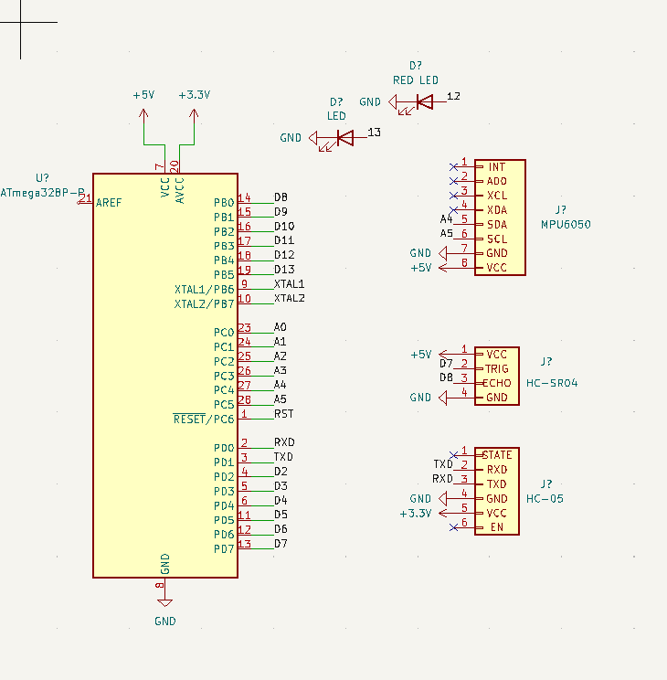

* Dependencies and Library need to install before proceed to running code:
* SoftwareSerial
* Wire: For I2C communication with the MPU6050 gyrometer sensor
* MPU6050 library.
* Setup :
* Serial Communication: Initializes the Serial monitor at a baud rate of 9600 for debugging purposes.
* I2C and Gyrometer Initialization: Sets up I2C communication and initializes the MPU6050 gyrometer sensor. The connection with the sensor is tested, and the results are printed to the Serial monitor.
* Bluetooth Initialization: Configures the SoftwareSerial library for Bluetooth communication at a baud rate of 9600.
* Ultrasonic Sensor Pins: Sets the trigger and echo pins of the ultrasonic sensor as output and input, respectively.
* Gyrometer Calibration: Calibrates the gyrometer by placing the sensor in a stable position for a few seconds. During this process, the gyrometer anchor values are determined to eliminate drift.
* LED control :
* Red LED: Turns on when the distance measured by the ultrasonic sensor is less than 5cm.
* Yellow LED: Turns on when the distance measured by the ultrasonic sensor is more than 50cm.
* Enter and run the coding. Link for Arduino full code from my GitHub account akimaziz:

[HC-SR04-HC-05-MPU6050-Project/gyro_test.ino at main · akimaziz/HC-SR04-HC-05-MPU6050-Project (github.com)](https://github.com/akimaziz/HC-SR04-HC-05-MPU6050-Project/blob/main/gyro_test.ino)

* Image from my smartphone below showed how the setup on the breadboard :

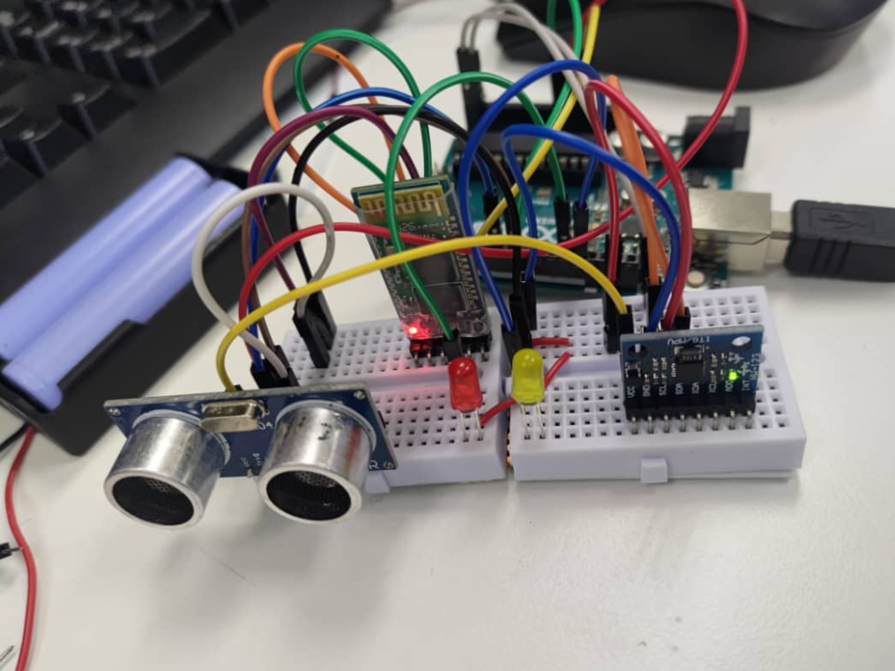

* Next image show the application install in android link with the data from the Arduino Serial Monitor:

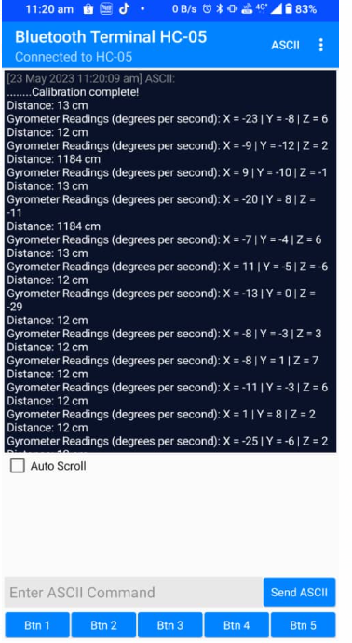

* This application call as Bluetooth Terminal HC-05 can represent the result of distance and gyrometer readings.